

March 31, 2012

TRAINING OUTCOME

Dear **«FullName»**,

Thank you for participating in the training that was conducted by Bridge International Academies from November 1, 2011 to December 15, 2011.

In reference to your Training Contract, we regret to inform you that you have not been selected to join Bridge International Academies.

We trust the training you received has equipped you with the necessary skills that will enable you to take up other opportunities in the future.

We confirm that we will not require you to repay the training costs referred to in your Training Contract.

We wish you success in your future endeavours.

Sincerely

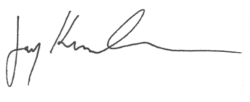

for **Bridge International Academies**